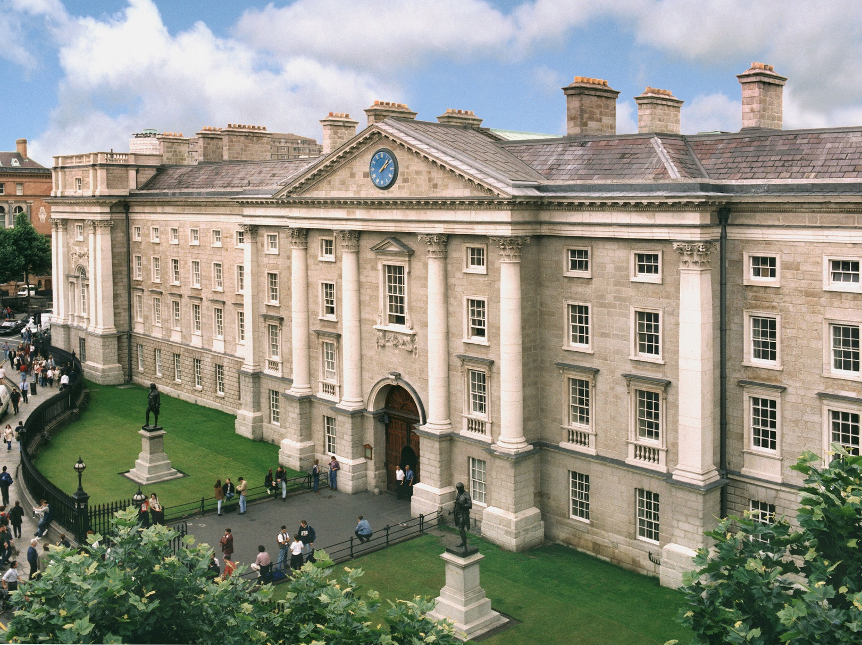
BESS & PPES
Senior Fresh and Junior Sophister
PATHWAY SELECTION INFORMATION BOOKLET 2024-2025

Contents

New Architecture Narrative 3

Common Architecture Visuals 5

Senior Fresh Pathways
Single Honour 7
Major/Minor 8
Joint Honour 10

Junior Sophister Pathways
Single Honour 13
Major/Minor 14
Joint Honour 16

New Architecture

A New Architecture was introduced in the 2019-20 academic year. Students now have the option to exit with a Single Honour, a Major with Minor, or a Joint Honour degree.
More information and Q&As for the Senior Fresh year pathway selection process is available here.
College Pathway selection and navigational tools available here.
BESS Handbook where information on available modules and Designated Open Modules can be found.
PPES Handbook where information on available modules and Designated Open Modules can be found.
Trinity Elective website: https://www.tcd.ie/trinity-electives/
Programme years (TCD Terminology)
Study Year | Trinity Label
1st year | Junior Fresh (JF)
2nd year | Senior Fresh (SF)
3rd year | Junior Sophister (JS)
4th year | Senior Sophister (SS)

Junior Fresh (first) Year
BESS students take 60 credits in their Junior Fresh year. 50 of the credits are mandatory and split over the four subjects: 10 credits in Business, 20 credits in Economics, 10 credits in Political Science, 10 credits in Sociology. A final 10 credits are to be taken from a list of core available modules such as Law, Social Policy, Languages (Irish, French, German, Spanish, Polish, Russian) etc.
PPES students take 60 credits in their Junior Fresh year with all 60 credits being mandatory: 20 credits in Philosophy, 20 credits in Economics, 10 credits in Political Science, 10 credits in Sociology.
Senior Fresh (second) Year
BESS & PPES Students choose 60 credits in their Senior Fresh year. Prior to entering into the Senior Fresh year (but after the publication of annual session results in their Junior Fresh year), students are invited by the Academic Registry to select, and register for a Pathway of their choice from within the four Subjects available to students of BESS (Business, Economics, Political Science, Sociology) and PPES (Philosophy, Political Science, Economics, Sociology).
The pathway you choose in your Senior Fresh year is not necessarily what you will choose to exit with i.e. you get a chance to change your pathway in the Junior Sophister year, if you wish to do so. Note, however, that if you choose to drop a subject in the second year you cannot re-select it in any subsequent year. Changing pathways in the Junior Sophister year is applicable to all pathways except for the Single Honour pathway (for which you drop all but one subject).
You can choose one of the following pathways:
- Single Honour (choosing 40 credits in the chosen Subject, 10 credits of Designated Optional Modules and 10 credits of Trinity Electives);
- Major with Minor (choosing 40 credits in Subject 1 and 20 credits in Subject 2);
- Joint Honour (choosing 20 credits in Subject 1, 20 credits in Subject 2, 10 credits of Designated Optional Modules, 10 credits in Trinity Electives) and, finally,
- Three Subjects/Triple Strand (choosing 20 credits in Subject 1, 20 credits in Subject 2, 20 credits in Subject 3).
The choice of pathway chosen in the Senior Fresh (second) year will determine the pathway choices available in the Junior Sophister (third) year.
Students are permitted to swap around their Major and Minor subjects when entering into the Junior Sophister year.
Junior Sophister (third) Year
Students choose 60 credits in their Junior Sophister year. Prior to entering into the Junior Sophister year, students are invited by the Academic Registry to select, and register for, their final choice of pathway (their exit pathway).
- Single Honour chosen in the Senior Fresh year, students will continue on the Single Honour pathway (50 credits in Subject 1 and 10 credits in Core Optional Modules);
- Major with Minor chosen in the Senior Fresh year, students can continue on the Major with Minor ‘A’ pathway (40 credits in Subject 1, 20 credits in Subject 2 in both JS and SS years) or continue on the Major with Minor ‘B’ pathway (30 credits in Subject 1, 30 credits in Subject 2, where in the SS year all 60 credits are in Subject 1) or transfer onto the Single Honour pathway in the Major Subject from the Senior Fresh year (50 credits in Subject 1, 10 credits of Designated Open Modules) or Joint Honour pathway (30 credits in Subject 1, 30 credits in Subject 2);
- Joint Honour chosen in the Senior Fresh year, students can continue on the Joint Honour pathway (30 credits in Subject 1, 30 credits in Subject 2) or transfer onto the Major with Minor pathway ‘A’ (40 credits in Subject 1, 20 credits in Subject 2 in both JS and SS years) or Major with Minor pathway ‘B’ (30 credits in Subject 1, 30 credits in Subject 2, in SS year 60 credits in Subject 1);
- Three Subjects chosen in the Senior Fresh year, students must now choose the Joint Honour pathway (30 credits in Subject 1, 30 credits in Subject 2) or the Major with Minor pathway ‘A’ (40 credits in Subject 1, 20 credits in Subject 2 in both JS and SS years) or Major with Minor pathway ‘B’ (30 credits in Subject 1, 30 credits in Subject 2, in SS year 60 credits in Subject 1);. Students are free to choose their subjects of choice from any of the three subjects taken in the Senior Fresh year. It is not possible to continue with Three Subjects.
Senior Sophister (fourth) year *
Students choose 60 credits in their Senior Sophister year. Depending on the final pathway chosen in the Junior Sophister (third) year students will study:
- Single Honour - 40 credits in Subject 1, 20 credits in Capstone Project from within Subject 1.
- Major with Minor ‘A’ - 20 credits in Subject 1, 20 credits in Subject 2, 20 credits in Capstone Project Subject 1 or Major with Minor ‘B’ 40 credits in Subject 1 and 20 credits in Capstone Project from within Subject 1.
- Joint Honour - 20 credits in Subject 1, 20 credits in Subject 2, 20 credits in Capstone Project from within either Subject 1 or 2 so long as any pre-requisite modules from earlier years are met.

*IT IS NOT POSSIBLE FOR STUDENTS TO MAKE PATHWAY CHANGE IN THEIR SENIOR SOPHISTER YEAR

PATHWAY CHOICES AVAILABLE IN THE SENIOR FRESH YEAR
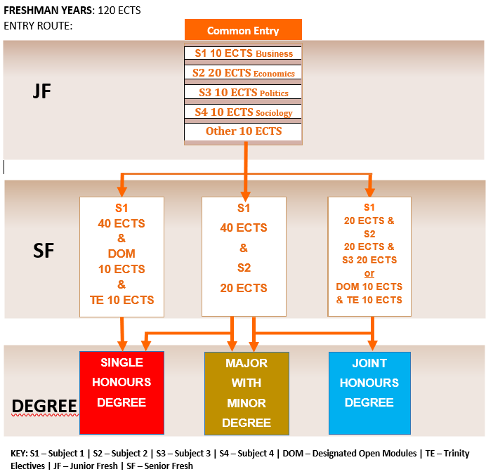
PPES: All modules mandatory – no Other 10 ECTs
PPES: Substitute Business with Philosophy S1 20 ECTS
PATHWAY CHOICES AVAILABLE IN THE JUNIOR SOPHISTER YEAR
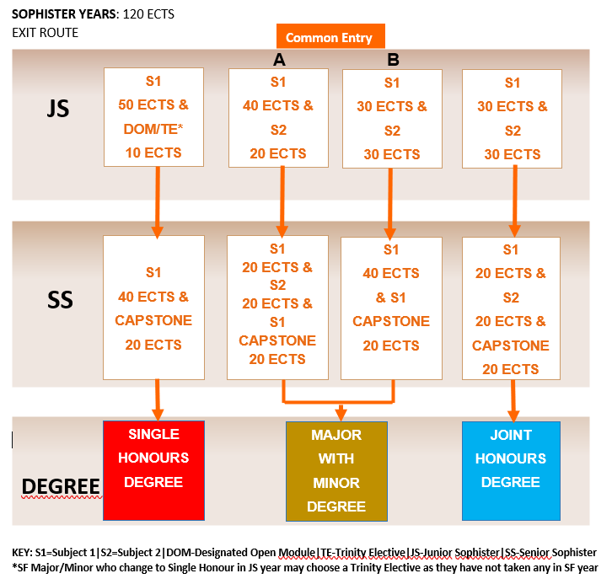

SENIOR FRESH
(SECOND) YEAR PATHWAYS
PATHWAY CHOICES AVAILABLE IN THE SENIOR FRESH (Second Year)
Students take 60 credits
SINGLE HONOUR BUSINESS/PHILOSOPHY

If you choose Single Honour Pathway in SF Year | If you choose Major With Minor Pathway in SF Year
Students take:  - 40 ECTS in Business/Philosophy  - 10 ECTS in Designated Open Modules  - 10 ECTS in Trinity Electives | Students take:  - 40 ECTS in Business/Philosophy  - 20 ECTS in Subject 2 (Economics, Politics or Sociology)
Will continue on Single Honour Business/Philosophy in the JS year | Can continue Major Business/Philosophy with Minor in the JS year or  Can swap the Major to be Minor, the Minor to be Major or  Can choose Single Honour Business/Philosophy in the JS year or  Can choose Joint Honour in Business/Philosophy and Subject 2

SINGLE HONOUR ECONOMICS

If you choose Single Honour Pathway in SF Year | If you choose Major Minor Pathway in SF Year
Students take:  - 40 ECTS in Economics  - 10 ECTS in Designated Open Modules  - 10 ECTS in Trinity Electives | Students take:  - 40 ECTS in Economics  - 20 ECTS in Subject 2 (Business/Philosophy, Politics or Sociology)
Will continue on Single Honour Economics in the JS year | Can continue Major Economics with Minor in the JS year or  Can swap the Major to be Minor, the Minor to be Major or  Can choose Single Honour Economics in the JS year or  Can choose Joint Honour in Economics and Subject 2

SINGLE HONOUR POLITICAL SCIENCE

If you choose Single Honour Pathway in SF Year | If you choose Major Minor Pathway in SF Year
Students take:  - 40 ECTS in Political Science  - 10 ECTS in Designated Open Modules  - 10 ECTS in Trinity Electives | Students take:  - 40 ECTS in Political Science  - 20 ECTS in Subject 2 (Business/Philosophy, Economics or Sociology)
Will continue on Single Honour Political Science in the JS year | Can continue Major Political Science with Minor in the JS or  Can swap the Major to be Minor, the Minor to be Major or  Can choose Single Honour Political Science in the JS year or  Can choose Joint Honour in Political Science and Subject 2

SINGLE HONOUR SOCIOLOGY

If you choose Single Honour Pathway in SF Year | If you choose Major Minor Pathway in SF Year
Students take:  - 40 ECTS in Sociology  - 10 ECTS in Designated Open Modules  - 10 ECTS in Trinity Electives | Students take:  - 40 ECTS in Sociology  - 20 ECTS in Subject 2 (Business/Philosophy, Economics or Political Science)
Will continue on Single Honour Sociology in the JS year | Can continue Major Sociology with Minor in the JS year or  Can swap the Major to be Minor, the Minor to be Major or  Can choose Single Honour Sociology in the JS year or  Can choose Joint Honour in Sociology and Subject 2
PATHWAY CHOICES AVAILABLE IN THE SENIOR FRESH (Second Year)
Students take 60 credits
MAJOR BUSINESS/PHILOSOPHY With Minor

If you choose Major with Minor Pathway in SF Year | If you choose Joint Honour Pathway in SF Year
Students take:  - 40 ECTS in Business/Philosophy  - 20 ECTS in Subject 2 (Economics, Politics or Sociology) | Students take:  - 20 ECTS in Business/Philosophy  - 20 ECTS in Subject 2 (Economics, Politics or Sociology)  - 10 ECTS in Trinity Electives  - 10 ECTS in Designated Open Modules
Can continue Joint Honour in the JS year or
Can choose Major ‘A’ or ‘B’ (in either Subject) with Minor in the JS year
 | If you choose Triple Strand Pathway in SF Year
Students take:
- 20 ECTS in Business/Philosophy
- 20 ECTS in Subject 2 (Economics, Politics or Sociology)
- 20 ECTS in Subject 3 (Economics, Politics or Sociology)
Can continue with Major Business with Minor in JS year or  Can swap the Major for Minor, the Minor for the Major or  Can choose Joint Honour in the JS year or  Can choose Single Honour Business in the JS year | Can choose Major ‘A‘ or ‘B’ (in any of three Subjects), with Minor, in the JS year or  Can choose Joint Honour in the JS year

MAJOR ECONOMICS With Minor

If you choose Major with Minor Pathway in SF Year | If you choose Joint Honour Pathway in SF Year
Students take:  - 40 ECTS in Economics  - 20 ECTS in Subject 2 (Business/Philosophy, Politics or Sociology) | Students take:  - 20 ECTS in Economics  - 20 ECTS in Subject 2 (Business/Philosophy, Politics or Sociology)  - 10 ECTS in Trinity Electives  - 10 ECTS in Designated Open Modules
Can continue Joint Honour in the JS year or
Can choose Major ‘A’ or ‘B’ (in either Subject) with Minor in the JS year
 | If you choose Triple Strand Pathway in SF Year
Students take:
- 20 ECTS in Economics
- 20 ECTS in Subject 2 (Business/Philosophy, Politics or Sociology)
- 20 ECTS in Subject 3 (Business/Philosophy, Politics or Sociology)
Can continue with Major Economics with Minor in JS year or  Can swap the Major for Minor, the Minor for the Major or  Can choose Joint Honour in the JS year or  Can choose Single Honour Economics in the JS year | Can choose Major ’A’ or ‘B’ (in any of three Subjects), with Minor, in the JS year or  Can choose Joint Honour in the JS year
In order to take Major in Sociology in the JS year, Capstone in Sociology in the SS year, students must choose SOU22011, SOU22012, SOU22061, SOU22062 in SF Year
In order to take Major in Political Science in the JS year, Capstone in Political Science in the SS year, students must choose POU22XXX in the SF Year.
PATHWAY CHOICES AVAILABLE IN THE SENIOR FRESH (Second Year)
Students take 60 credits
MAJOR POLITICAL SCIENCE With Minor

If you choose Major with Minor Pathway in SF Year | If you choose Joint Honour Pathway in SF Year
Students take:  - 40 ECTS in Political Science  - 20 ECTS in Subject 2 (Economics, Business/ Philosophy or Sociology) | Students take:  - 20 ECTS in Political Science  - 20 ECTS in Subject 2 (Economics, Business/ Philosophy or Sociology)  - 10 ECTS in Trinity Electives  - 10 ECTS in Designated Open Modules
Can continue Joint Honour in the JS year or
Can choose Major ‘A’ or ‘B (in either Subject) with Minor in the JS year
 | If you choose Triple Strand Pathway in SF Year
Students take:
- 20 ECTS in Political Science
- 20 ECTS in Subject 2 (Business/ Philosophy, Economics or Sociology)
- 20 ECTS in Subject 3 (Business/Philosophy, Economics or Sociology)
Can continue with Major Politics with Minor in JS year or  Can swap the Major for Minor, the Minor for the Major or  Can choose Joint Honour in the JS year or  Can choose Single Honour Political Science in the JS year | Can choose Major ‘A’ or ‘B’ (in any of 3 Subjects), with Minor, in the JS year or  Can choose Joint Honour in the JS year

MAJOR SOCIOLOGY With Minor

If you choose Major with Minor Pathway in SF Year | If you choose Joint Honour Pathway in SF Year
Students take:  - 40 ECTS in Sociology  - 20 ECTS in Subject 2 (Economics, Politics or Business/Philosophy) | Students take:  - 20 ECTS in Sociology  - 20 ECTS in Subject 2 (Business/Philosophy, Politics or Economics)  - 10 ECTS in Trinity Electives  - 10 ECTS in Designated Open Modules
Can continue Joint Honour in the JS year or
Can choose Major ‘A’ or ‘B’ (in either Subject) with Minor in the JS year
 | If you choose Triple Strand Pathway in the SF Year
Students take:
- 20 ECTS in Sociology
- 20 ECTS in Subject 2 (Business/Philosophy, Politics or Economics)
- 20 ECTS in Subject 3 (Business/Philosophy, Politics or Economics)
Can continue with Major Sociology with Minor in JS year or  Can swap the Major for Minor, the Minor for the Major or  Can choose Joint Honour in the JS year or  Can choose Single Honour Sociology in the JS year | Can choose Major ‘A’ or ‘B’ (in any of 3 Subjects), with Minor, in the JS year or  Can choose Joint Honour in the JS year
In order to take Major in Sociology in the JS year, Capstone in Sociology in the SS year, students must choose SOU22011, SOU22012, SOU22061, SOU22062 in SF Year
In order to take Major in Political Science in the JS year, Capstone in Political Science in the SS year, students must choose POU22XXX in the SF Year.
PATHWAY CHOICES AVAILABLE IN THE SENIOR FRESH (Second Year)
Students take 60 credits
JOINT HONOUR BUSINESS/PHILOSOPHY

If you choose Joint Honour in SF Year | If you choose Triple Strand Pathway in SF Year
Students take:  - 20 ECTS in Business/Philosophy  - 20 ECTS in Subject 2 (Economics, Politics or Sociology)  - 10 ECTS in Trinity Elective  - 10 ECTS in Designated Open Modules | Students take:  - 20 ECTS in Business/Philosophy  - 20 ECTS in Subject 2 (Economics, Politics or Sociology)  - 20 ECTS in Subject 3 (Economics, Politics or Sociology)
Can choose Major ‘A’ or ‘B’ (in either Subject), with Minor, in the JS year or
Can continue Joint Honour in the JS year
 | If you choose Major with Minor Pathway in SF Year
Students take:
- 40 ECTS in Business/Philosophy
- 20 ECTS in Subject 2 (Economics, Politics or Sociology)
Can continue with Joint Honour in JS year or  Can choose Major (either Subject) with Minor in the JS year | Can continue Major Minor Business/Philosophy ‘A’ or ‘B’ in the JS year or  Can Swap Major Business/Philosophy to be Minor subject, Minor subject becomes Major subject, in JS year or  Can choose Joint Honour in the JS year

JOINT HONOUR ECONOMICS

If you choose Joint Honour in SF Year | If you choose Triple Strand Pathway in SF Year
Students take:  - 20 ECTS in Economics  - 20 ECTS in Subject 2 (Business/Philosophy, Politics or Sociology)  - 10 ECTS in Trinity Elective  - 10 ECTS in Designated Open Modules | Students take:  - 20 ECTS in Economics  - 20 ECTS in Subject 2 (Business/Philosophy, Politics or Sociology)  - 20 ECTS in Subject 3 (Business/Philosophy, Politics or Sociology)
Can choose Major ‘A’ or ‘B’ (in either Subject), with Minor, in the JS year or
Can choose Joint Honour in the JS year
 | Major with Minor Pathway in SF Year
Students take:
- 40 ECTS in Economics
- 20 ECTS in Subject 2 (Business/Philosophy, Politics or Sociology)
Can continue with Joint Honour in JS year or  Can choose Major (either Subject) with Minor in the JS year | Can continue Major Economics/Minor ‘A’ or ‘B’ in the JS year or  Can Swap Major Economics to be Minor subject, Minor subject becomes Major subject, in JS year or  Can choose Joint Honour in the JS year
In order to take Major in Sociology in the JS year, Capstone in Sociology in the SS year, students must choose SOU22011, SOU22012, SOU22061, SOU22062 in SF Year
In order to take Major in Political Science in the JS year, Capstone in Political Science in the SS year, students must choose POU22XXX in the SF Year.
JOINT HONOUR POLITICAL SCIENCE

If you choose Joint Honour in SF Year | If you choose Triple Strand Pathway in SF Year
Students take:  - 20 ECTS in Political Science  - 20 ECTS in Subject 2 (Business/Philosophy, Economics or Sociology)  - 10 ECTS in Trinity Elective  - 10 ECTS in Designated Open Modules | Students take:  - 20 ECTS in Political Science  - 20 ECTS in Subject 2 (Business/Philosophy, Economics or Sociology)  - 20 ECTS in Subject 3 (Business/Philosophy, Economics or Sociology)
Can choose Major ‘A’ or ‘B’ (in either Subject) with Minor in the JS year or
Can choose Joint Honour in the JS year

 | Major with Minor Pathway in SF Year
Students take:
- 40 ECTS in Political Science
- 20 ECTS in Subject 2 (Business/Philosophy, Economics or Sociology)
Can continue with Joint Honour in JS year or  Can choose Major (either Subject) with Minor in the JS year | Can continue Major Politics/Minor ‘A’ or ‘B’ in the JS year or  Can Swap Major Politics to be Minor subject, Minor subject becomes Major subject, in JS year or  Can choose Joint Honour in the JS year

JOINT HONOUR SOCIOLOGY

If you choose Joint Honour in SF Year | If you choose Triple Strand Pathway in SF Year
Students take:  - 20 ECTS in Sociology  - 20 ECTS in Subject 2 (Business/Philosophy, Economics or Politics)  - 10 ECTS in Trinity Elective  - 10 ECTS in Designated Open Modules | Students take:  - 20 ECTS in Sociology  - 20 ECTS in Subject 2 (Business/Philosophy, Economics or Politics)  - 20 ECTS in Subject 3 (Business/Philosophy, Economics or Politics)
Can choose Major ‘A’ or ‘B’ (in any of 3 Subjects), with Minor, in the JS year or
Can choose Joint Honour in the JS year

 | Major with Minor Pathway in SF Year
Students take:
- 40 ECTS in Sociology
- 20 ECTS in Subject 2 (Business/Philosophy, Economics or Politics)
Can continue with Joint Honour in JS year or  Can choose Major (either Subject) with Minor in the JS year | Can continue Major Sociology/Minor ‘A’ or ‘B’ in the JS year or  Can Swap Major Sociology to be Minor subject, Minor subject becomes Major subject, in JS year or  Can choose Joint Honour in the JS year

In order to take Major in Sociology in the JS year, Capstone in Sociology in the SS year, students must choose SOU22011, SOU22012, SOU22061, SOU22062 in SF Year
In order to take Major in Political Science in the JS year, Capstone in Political Science in the SS year, students must choose POU22XXX in the SF Year.

JUNIOR SOPHISTER
(THIRD) YEAR PATHWAYS

PATHWAY CHOICES AVAILABLE IN THE JUNIOR SOPHISTER (Third Year)
Students take 60 credits
SINGLE HONOUR BUSINESS/PHILOSOPHY

If you choose Single Honour Pathway in JS Year | Single Honour in the SS Year
Students take:  - 50 ECTS in Business/Philosophy  - 10 ECTS in Designated Open Modules | Students take:  - 40 ECTS in Business/Philosophy  - 20 ECTS Business/Philosophy Capstone
Will continue on Single Honour in the SS year | Exit with PRO (BBS) or BA (MOD). Transcript will show the Single Honour Pathway

SINGLE HONOUR ECONOMICS

If you choose Single Honour Pathway in JS Year | Single Honour in the SS Year
Students take:  - 50 ECTS in Economics  - 10 ECTS in Designated Open Modules | Students take:  - 40 ECTS in Economics  - 20 ECTS Economics Capstone
Will continue on Single Honour in the SS year | Exit with BA (MOD). Transcript will show the Single Honour Pathway

SINGLE HONOUR POLITICAL SCIENCE

If you choose Single Honour Pathway in JS Year | Single Honour in the SS Year
Students take:  - 50 ECTS in Political Science  - 10 ECTS in Designated Open Modules | Students take:  - 40 ECTS in Political Science  - 20 ECTS Political Science Capstone
Will continue on Single Honour in the SS year | Exit with BA (MOD). Transcript will show the Single Honour Pathway

SINGLE HONOUR SOCIOLOGY

If you choose Single Honour Pathway in JS Year | Single Honour in the SS Year
Students take:  - 50 ECTS in Sociology  - 10 ECTS in Designated Open Modules | Students take:  - 40 ECTS in Sociology  - 20 ECTS Sociology Capstone
Will continue on Single Honour in the SS year | Exit with BA (MOD). Transcript will show the Single Honour Pathway

PATHWAY CHOICES AVAILABLE IN THE JUNIOR SOPHISTER (Third Year)
Students take 60 credits
MAJOR BUSINESS/PHILOSOPHY With Minor – Option ‘A’

If you choose Major Business with Minor in JS Year | Major Business with Minor in the SS Year
Students take:  - 40 ECTS in Business/Philosophy  - 20 ECTS in Minor Subject taken in SF Year | Students take:  - 40 ECTS in Business/Philosophy (to include Capstone)  - 20 ECTS in Minor Subject
Will continue with Major Minor in the SS year | Exit with PRO (BBS) or BA (MOD). Transcript will show the Major Minor Pathway
OR
MAJOR BUSINESS/PHILOSOPHY With Minor – Option ‘B’

Students take:  - 30 ECTS in Business/Philosophy  - 30 ECTS in Minor Subject taken in SF Year | Students take:  - 60 ECTS in Business/Philosophy (20 ECTS of which will be the Capstone
Will continue with Major Minor in the SS year | Exit with PRO (BBS) or BA (MOD). Transcript will show the Major Minor Pathway

MAJOR ECONOMICS With Minor – Option ‘A’

If you choose Major Economics with Minor in JS Year | Major Economics with Minor in the SS Year
Students take:  - 40 ECTS in Economics  - 20 ECTS in Minor Subject taken in SF Year | Students take:  - 40 ECTS in Economics (to include Capstone)  - 20 ECTS in Minor Subject
Will continue with Major Minor in the SS year | Exit with BA (MOD). Transcript will show the Major Minor Pathway
OR
MAJOR ECONOMICS With Minor – Option ‘B’

Students take:  - 30 ECTS in Economics  - 30 ECTS in Minor Subject taken in SF Year | Students take:  - 60 ECTS in Economics (20 ECTS of which will be the Capstone
Will continue with Major Minor in the SS year | Exit with BA (MOD). Transcript will show the Major Minor Pathway

Capstone in Political Science requires prerequisites (POU22XXX if exiting 2027), POU33011 and POU33012
Capstone in Sociology requires prerequisites SOU22011, SOU22012, SOU22061, SOU22062, SOU33011, SOU33012
Capstone in Economics requires prerequisites ECU33091 and ECU33092
MAJOR POLITICAL SCIENCE With Minor – Option ‘A’

If you choose Major Politics with Minor in JS Year | Major Politics with Minor in the SS Year
Students take:  - 40 ECTS in Political Science  - 20 ECTS in Minor Subject taken in SF Year | Students take:  - 40 ECTS in Political Science (to include Capstone)  - 20 ECTS in Minor Subject
Will continue with Major Minor in the SS year | Exit with BA (MOD). Transcript will show the Major Minor Pathway
OR
MAJOR POLITICAL SCIENCE With Minor – Option ‘B’

Students take:  - 30 ECTS in Political Science  - 30 ECTS in Minor Subject taken in SF Year | Students take:  - 60 ECTS in Political Science (20 ECTS of which will be the Capstone
Will continue with Major Minor in the SS year | Exit with BA (MOD). Transcript will show the Major Minor Pathway

MAJOR SOCIOLOGY With Minor – Option ‘A’

If you choose Major Sociology with Minor in JS Year | Major Sociology with Minor in the SS Year
Students take:  - 40 ECTS in Sociology  - 20 ECTS in Minor Subject taken in SF Year | Students take:  - 40 ECTS in Sociology (to include Capstone)  - 20 ECTS in Minor Subject
Will continue with Major Minor in the SS year | Exit with BA (MOD). Transcript will show the Major Minor Pathway
OR
MAJOR SOCIOLOGY With Minor – Option ‘B’

Students take:  - 30 ECTS in Sociology  - 30 ECTS in Minor Subject taken in SF Year | Students take:  - 60 ECTS in Sociology (20 ECTS of which will be the Capstone
Will continue with Major Minor in the SS year | Exit with BA (MOD). Transcript will show the Major Minor Pathway

Capstone in Political Science requires prerequisites (POU22XXX if exiting 2027), POU33011 and POU33012
Capstone in Sociology requires prerequisites SOU22011, SOU22012, SOU22061, SOU22062, SOU33011, SOU33012
Capstone in Economics requires prerequisites ECU33091 and ECU33092
PATHWAY CHOICES AVAILABLE IN THE JUNIOR SOPHISTER (Third Year)
Students take 60 credits
JOINT HONOUR BUSINESS/PHILOSOPHY

If you choose Joint Honour Business in JS Year | Joint Honour Business in the SS Year
Students take:  - 30 ECTS in Business/Philosophy  - 30 ECTS in Subject 2 or 3 taken in SF Year | Students take:  - 20 ECTS in Business/Philosophy  - 20 ECTS in Subject 2  - 20 ECTS Capstone can be in either Subject, if pre-requisite compliant
Will continue with Joint Honour in the SS year | Exit with PRO (BBS) or BA (MOD). Transcript will show the Joint Honour Pathway

JOINT HONOUR ECONOMICS

If you choose Joint Honour Economics in JS Year | Joint Honour Economics in the SS Year
Students take:  - 30 ECTS in Economics  - 30 ECTS in Subject 2 or 3 taken in SF Year | Students take:  - 20 ECTS in Economics  - 20 ECTS in Subject 2  - 20 ECTS Capstone can be in either Subject if pre-requisite compliant
Will continue with Joint Honour in the SS year | Exit with BA (MOD). Transcript will show the Joint Honour Pathway

JOINT HONOUR POLITICAL SCIENCE

If you choose Joint Honour Political Science in JS Year | Joint Honour Political Science in the SS Year
Students take:  - 30 ECTS in Political Science  - 30 ECTS in Subject 2 or 3 taken in SF Year | Students take:  - 20 ECTS in Political Science  - 20 ECTS in Subject 2  - 20 ECTS Capstone can be in either Subject if pre-requisite compliant
Will continue with Joint Honour in the SS year | Exit with BA (MOD). Transcript will show the Joint Honour Pathway

MAJOR SOCIOLOGY With Minor

If you choose Joint Honour Sociology in JS Year | Joint Honour Sociology in the SS Year
Students take:  - 30 ECTS in Sociology  - 30 ECTS in Subject 2 or 3 taken in SF Year | Students take:  - 20 ECTS in Sociology  - 20 ECTS in Subject 2  - 20 ECTS Capstone can be in either Subject if pre-requisite compliant
Will continue with Joint Honour in the SS year | Exit with BA (MOD). Transcript will show the Joint Honour Pathway

Capstone in Political Science requires prerequisites (POU22XXX if exiting 2027), POU33011 and POU33012
Capstone in Sociology requires prerequisites SOU22011, SOU22012, SOU22061, SOU22062, SOU33011, SOU33012
Capstone in Economics requires prerequisites ECU33091 and ECU33092

